***NAME: FATHIMA KHADER***

***DATE: 0710/2023***

**DATA ANALYSIS AND REGRESSION PROJECT REPORT**

The dataset that I used for this project is Airline Delay Analysis which checks the delay in the flight. It makes use of *Arrival Delay* as dependent variable and several independent variables: *YEAR, MONTH, DAY, DAY_OF_WEEK, AIRLINE, ORIGIN_AIRPORT, DESTINATION_AIRPORT, SCHEDULED_DEPARTURE, DEPARTURE_TIME, DEPARTURE_DELAY, DISTANCE, TAXI_OUT, AIR_TIME, ELAPSED_TIME, TAXI_IN, and CANCELLED*

*import data from file;

proc import datafile="f2.csv" out=flight replace;

delimiter=',';

getnames=yes;

run;

printing the first 5 observations we get :

Look at fig.1 for reference

The data in this dataset consists of the right naming convention for the variables. The issue with this dataset is that a few of the rows here have missing values. In order to use this data we need to solve this issue. For this, I have used the approach of deleting rows that have missing values.

/* Delete rows with missing values */

data flights_cleaned;

set flight;

if not missing(ARRIVAL_DELAY) and not missing(year) and not missing(month) and not missing(Day) and not missing(Day_of_week)and not missing(Airline) and not missing(origin_airport) and not missing(destination_airport) and not missing(scheduled_departure) and not missing(Departure_time) and not missing(departure_delay) and not missing(distance) and not missing(taxi_out) and not missing(air_time) and not missing(elapsed_time) and not missing(taxi_in) and not missing(cancelled) ;

run;

Data exploration consists of multiple ways to explore data. The different approaches I used here are :

5-point summary :

Looking at Fig 2 we can infer a few things of about the dataset :

The percentage of arrival delay ranges from -82 to 1971. The median value of arrival delay is -3.0%. Since there is a higher value at the 75th percentile, it suggests that there are instances of significant arrival delays in some flights. For month the values range from 1 to 12, representing the months of the year. There is no specific observation mentioned regarding the summary statistics or any patterns. DAY_OF_WEEK: The values range from 1 to 7, representing the days of the week. SCHEDULED_DEPARTURE: The values range from 1 to 2359, representing the scheduled departure time. DEPARTURE_TIME: The values range from 1 to 2400, representing the actual departure time. DEPARTURE_DELAY: The values range from -61 to 1988, representing the departure delay in minutes. The median value (50th percentile) of departure delay is -5 minutes, and the 75th percentile is 11 minutes. DISTANCE: The values range from 31 to 4983, representing the distance of the flight in miles. The median distance (50th percentile) is 366 miles, and the 75th percentile is 641 miles. TAXI_OUT: The values range from 1 to 225, representing the time taken for the aircraft to taxi out in minutes. The median time (50th percentile) for taxiing out is 11 minutes, and the 75th percentile is 19 minutes. AIR_TIME: The values range from 7 to 687, representing the actual flight time in minutes. The median air time (50th percentile) is 60 minutes, and the 75th percentile is 144 minutes. ELAPSED_TIME: The values range from 15 to 766, representing the total elapsed time of the flight in minutes. The median elapsed time (50th percentile) is 82 minutes, and the 75th percentile is 169 minutes. TAXI_IN: The values range from 1 to 202, representing the time taken for the aircraft to taxi in after landing in minutes. The median time (50th percentile) for taxiing in is 4 minutes, and the 75th percentile is 9 minutes.

Frequency:

Here is the interpretation for each airline based on the above frequency and percentage distribution from fig 3:

- AA: The airline "AA" represents 9.29% of the flights in the dataset, with a frequency count of 94,417. This indicates that it is one of the major airlines in the dataset. The airline "AS" represents 2.82% of the flights, with a frequency count of 28,672. It has a lower percentage compared to AA, suggesting a smaller presence in the dataset. The airline "B6" represents 4.59% of the flights, with a frequency count of 46,611. It has a moderate presence in the dataset. The airline "DL" represents 14.11% of the flights, with a frequency count of 143,377. It has a relatively high percentage, indicating a significant number of flights operated by this airline. The airline "EV" represents 10.61% of the flights, with a frequency count of 107,789. It has a substantial presence in the dataset. The airline "F9" represents 1.39% of the flights, with a frequency count of 14,153. It has a relatively lower percentage compared to other airlines. The airline "HA" represents 1.35% of the flights, with a frequency count of 13,687. It has a relatively smaller presence in the dataset. The airline "MQ" represents 6.24% of the flights, with a frequency count of 63,435. It has a significant percentage and indicates a notable number of flights. The airline "NK" represents 1.87% of the flights, with a frequency count of 19,028. It has a relatively lower presence compared to other airlines. The airline "OO" represents 10.20% of the flights, with a frequency count of 103,662. It has a substantial percentage, suggesting a significant number of flights operated by this airline. The airline "UA" represents 8.35% of the flights, with a frequency count of 84,798. It has a notable percentage and indicates a considerable number of flights. The airline "US" represents 7.04% of the flights, with a frequency count of 71,545. It has a substantial presence in the dataset. The airline "VX" represents 0.99% of the flights, with a frequency count of 10,043. It has a relatively lower percentage compared to other airlines. The airline "WN" represents 21.13% of the flights, with a frequency count of 214,696. It has the highest percentage among all the airlines, indicating a significant number of flights operated by this airline. These interpretations provide insights into the distribution and prevalence of flights among different airlines in the dataset.

Boxplot:

From this Fig. 4 boxplot, we can only interpret that there isn’t much difference in the arrival delay for the flights each month. We can notice the presence of outliers.

Histogram:

From Fig.5 Looking at the histogram, we see that the distribution is not symmetric. It is skewed to the right, indicating the presence of a few high values in the variable. We can also observe the presence of outliers. We can that the arrival delay is concentrated mainly between 0 to 500. It can also be seen that the maximum percent that is 30% of the delay is 0.

Correlation :

From Fig.6, we can see that month has almost no relation with arrival_delay. Scheduled_Departure also has almost 0 correlation with arrival_delay. Departure_delay has a strong positive correlation with arrival_delay. Distance has a very low negative almost zero correlation with arrival_delay. Taxi_out has a positive very low correlation with arrival_delay. Air_time and elapsed_time have no correlation with arrival_delay. Taxi_in has a very low positive correlation with arrival_delay.

Scatterplot:

Note: I did separate scatterplots for each variable because my system was processing for hours and not giving any output for the scatterplot code for all variables in a single plot.

Looking at fig.7.a- fig7.i, we can make conclusions on the linearity of these independent variables with the dependent variable. Out of all these, the only independent variable that has a high correlation and linear relationship with arrival_delay is departure_delay. Rest all of the other independent variables don’t seem to have a linear relationship with the dependent variable. Taxi_in and Taxi_out have a very low correlation with arrival_delay. We can notice that the assumption of linearity is not satisfied.

Proc reg;

title "regression";

model arrival_delay= year month day_of_week scheduled_departure departure_time departure_delay distance taxi_out air_time elapsed_time taxi_in;

run;

From Fig 8 , the provided table represents the parameter estimates for the variables in the model. Here is the interpretation for each variable: Intercept: The estimated intercept value is -25.24784. This represents the expected value of the dependent variable when all other independent variables are zero. YEAR: The parameter estimate for the variable YEAR is not available (indicated by "0 . . ."). This suggests that the variable YEAR may not be included in the model or its estimate is not applicable. MONTH: The parameter estimate for the variable MONTH is 0.27203. It indicates that a one-unit increase in the MONTH variable is associated with an estimated increase of 0.27203 units in the dependent variable. DAY_OF_WEEK: The parameter estimate for the variable DAY_OF_WEEK is -0.00888. It suggests that a one-unit increase in the DAY_OF_WEEK variable is associated with an estimated decrease of 0.00888 units in the dependent variable. However, the p-value (0.0696) indicates that this estimate is not statistically significant at the conventional significance level of 0.05. SCHEDULED_DEPARTURE: The parameter estimate for the variable SCHEDULED_DEPARTURE is 0.00237. It suggests that a one-unit increase in the SCHEDULED_DEPARTURE variable is associated with an estimated increase of 0.00237 units in the dependent variable. DEPARTURE_TIME: The parameter estimate for the variable DEPARTURE_TIME is -0.00091097. It indicates that a one-unit increase in the DEPARTURE_TIME variable is associated with an estimated decrease of 0.00091097 units in the dependent variable. DEPARTURE_DELAY: The parameter estimate for the variable DEPARTURE_DELAY is 0.99446. It suggests that a one-unit increase in the DEPARTURE_DELAY variable is associated with an estimated increase of 0.99446 units in the dependent variable. DISTANCE: The parameter estimate for the variable DISTANCE is -0.02832. It indicates that a one-unit increase in the DISTANCE variable is associated with an estimated decrease of 0.02832 units in the dependent variable. TAXI_OUT: The parameter estimate for the variable TAXI_OUT is -0.00898. It suggests that a one-unit increase in the TAXI_OUT variable is associated with an estimated decrease of 0.00898 units in the dependent variable. AIR_TIME: The parameter estimate for the variable AIR_TIME is -0.60182. It indicates that a one-unit increase in the AIR_TIME variable is associated with an estimated decrease of 0.60182 units in the dependent variable. ELAPSED_TIME: The parameter estimate for the variable ELAPSED_TIME is 0.80436. It suggests that a one-unit increase in the ELAPSED_TIME variable is associated with an estimated increase of 0.80436 units in the dependent variable. TAXI_IN: The parameter estimate for the variable TAXI_IN is not available (indicated by "0 . . ."). This suggests that the variable TAXI_IN may not be included in the model or its estimate is not applicable. CANCELLED: The parameter estimate for the variable CANCELLED is not available (indicated by "0 . . ."). This suggests that the variable CANCELLED may not be included in the model or its estimate is not applicable.

Out of all the variables, from fig., we notice that day_of_week is the only insignificant variable.

The r-square and adj r-square values are 0.9472 each. This is a pretty high value. Removing the insignificant value should improve.

On conducting a global f test,

null hypothesis: None of the x variables included in the model has any association with y.

Alternate hypothesis: At least one x variable has a significant effect on changes in y.

The test statistic: F= MS ( Regression)/ MS ( Residual)

We also get the f-test value from the analysis of the variance table. Here it is, 2181866.

Since the f-value is high and the p-value is very low. We reject the null hypothesis and go with the alternate hypothesis and say that there is at least one predictor that can predict the arrival_delay.

Rank variables based on their imporatance:

From Fig.10 , we can rank the variables based on their standardized estimates :

Based on the standardized estimates provided, the variables can be ranked in order of their importance as follows:

1. **ELAPSED_TIME:** The standardized estimate for ELAPSED_TIME is 1.40699, indicating that it has the highest importance among the variables in the model. **2. DEPARTURE_DELAY**: The standardized estimate for DEPARTURE_DELAY is 0.91998, suggesting that it is the second most important variable. **3. DISTANCE:** The standardized estimate for DISTANCE is -0.39910, implying that it has a moderate level of importance in relation to the other variables. **4. AIR_TIME**: The standardized estimate for AIR_TIME is -1.02291, indicating its relatively lower importance compared to the other variables. **5. SCHEDULED_DEPARTURE**: The standardized estimate for SCHEDULED_DEPARTURE is 0.02635, suggesting a lesser importance compared to the above variables. **6. MONTH**: The standardized estimate for MONTH is 0.00455, indicating a very small effect on the dependent variable. **7. DEPARTURE_TIME:** The standardized estimate for DEPARTURE_TIME is -0.01039, implying a minimal impact on the dependent variable**. 8. TAXI_OUT:** The standardized estimate for TAXI_OUT is -0.00214, suggesting a negligible influence on the dependent variable.

We need to check the assumptions of linearity, normality, independence and constant variance. The diagnostics that we need to check include influential points, outliers and multicollinearity.

From the above figures 11.a- 11.h we can conclude that , constant variance and independence are not satisfied as we can see some patterns in these graphs. From fig, 7.a – 7.i we can say that linearity is not satisfied. However, from Fig 11.i we can see that normality is the only assumption that is satisfied.

Checking for multicollinearity:

On looking at the fig for multicollinearity, we observe that Month has a VIF of 1.00, indicating a low level of multicollinearity. Scheduled_Departure has a VIF of 18.54, indicating a high level of multicollinearity. Similarly, Departure_time has a VIF of 18.92, indicating high level of multicollinearity. Departure_Delay and Taxi_Out has Vif<10 therefore, they have low level of multicollinearity. Air_Time, Elapsed_Time and Distance have very high level of multicollinearity. In order to get rid of this multicollinearity we’ll need to eliminate those columns that have a vif>10. So in this case the columns we’ll be removing are in the decreasing order of their vifs. We’ll remove one column at a time and check if the values have changed for other and then decide what to remove next. So the final columns we come up with are : Departure_Time, Air_Time, Elapsed_Time

Check for Outliers and Influential Points:

On running the code im getting a very huge output as my data set it too large so ill just mention few of the rows that are both outliers and influential points with arrow heads. We’ll go ahead and remove these and re run our model and finally generate full model equation.

Rows to remove: 10, 16, 23 58, 77, 91, 99, 115, 183, 187, 201, 265, 287, 300, 365, 419, 790, 1008, 5999 etc

*outliers and influential removal;

**Data** golf_new;

Set golf;

If _n_ in (**10,** 16, 23 58, 77, 91, 99, 115, 183, 187, 201, 265, 287, 300, 365, 419, 790, 1008, 5999 ) then delete;

**Run**;

Generating model equation:

Arrival_Delay= -22.033 + 0.2 month+ 0.0012 Scheduled_Departure+ 0.99 Departure_Delay- 0.004 Distance+ 0.82 Taxi_Out+ 0.81 Taxi_in

Month: For every unit increase in Month, Arrival_Delay is expected to increase by 0.2 units, assuming all other variables remain constant. This suggests that there might be certain months where Arrival_Delay tends to be higher or lower compared to other months. Scheduled_Departure: For every unit increase in Scheduled_Departure, Arrival_Delay is expected to increase by 0.0012 units, assuming all other variables remain constant. This indicates that flights with later scheduled departure times may experience slightly higher Arrival_Delay. Departure_Delay: For every unit increase in Departure_Delay, Arrival_Delay is expected to increase by 0.99 units, assuming all other variables remain constant. This implies that delays in departure time have a strong positive impact on Arrival_Delay. Distance: For every unit increase in Distance, Arrival_Delay is expected to decrease by 0.004 units, assuming all other variables remain constant. This suggests that longer-distance flights may have slightly lower Arrival_Delay compared to shorter-distance flights. Taxi_Out: For every unit increase in Taxi_Out, Arrival_Delay is expected to increase by 0.82 units, assuming all other variables remain constant. This indicates that longer taxi-out times at the departure airport are associated with higher Arrival_Delay. Taxi_In: For every unit increase in Taxi_In, Arrival_Delay is expected to increase by 0.81 units, assuming all other variables remain constant. This suggests that longer taxi-in times at the arrival airport are associated with higher Arrival_Delay.

We now split the data into training and testing set. Fig. 15 is what w obtained on dividing the data into training and testing set. After this, we use a model selection technique to select a model and make computations and predictions on it. Here I used Adjrsq selection technique and on the basis of that technique I came up with the following set of independent variables: month scheduled_departure departure_delay distance taxi_out taxi_in.

Next step is to check the performance, since we are only using one model we compare the training and testing set performance with eachother.

Fig.17 shows the statistics for model 1. Fig .18 show the rmse , mae and other values for model 1. Lets us compare the rmse and r square values for training and test set and check the performance. We can see that the rmse value for train set is: 10.14932 for test set: 10.1142 and the r square for train: 0.9420 for test: 0.9432. Looking at these values we can say that the test set is better in terms of both of these although there is only a slight difference between each of these values. Since the test set is doing slightly better than the train set we can safely conclude that the model is good.

Before generating the final model equation, let’s first check the diagnostics and assumptions. From fig.20.a- fig.20.h, we can say that linearity, constant variance and independence are not satisfied. Further, on checking the outliers and influential points, we find a few outliers and influential points that needs to be taken care of. After removing those few rows let’s check for multicollinearity. From Fig 21 we can see that the vif values for all the variables are less than 10 so this indicates there is no issue of multicollinearity in this model. We can see that the r-square and adj r-sq values are 0.9423 each. R2 and Adj-R2 c indicate how good a model is. It indicates the variation in Y explained by the regression model.. It means that 94.23% of the variation in arrival delay is explained by its relationship with month, scheduled_departure, departure_delay, distance, taxi_out, taxi_in . Similarly, Adj R-sq indicates the same thing. Here its 94.23% of the variation in graduation rate is explained by its relationship with month, scheduled_departure, departure_delay, distance, taxi_out, taxi_in. Looking at the r square and adj r square value we can see that this model is very good at making predictions.

Arrival_delay= -22.03 + 0.27 month+ 0.0012 scheduled_departure + 0.99 departure_delay -0.00443 distance + 0.82 taxi_out + 0.81 taxi_in

Based on the given equation:

Here is the effect of each independent variable on the Arrival_delay: month: For every one-unit increase in the month, the Arrival_delay is expected to increase by 0.27 units, assuming all other variables remain constant. scheduled_departure: For every one-unit increase in the scheduled_departure, the Arrival_delay is expected to increase by 0.0012 units, assuming all other variables remain constant. departure_delay: For every one-unit increase in the departure_delay, the Arrival_delay is expected to increase by 0.99 units, assuming all other variables remain constant. distance: For every one-unit increase in the distance, the Arrival_delay is expected to decrease by 0.00443 units, assuming all other variables remain constant. taxi_out: For every one-unit increase in the taxi_out, the Arrival_delay is expected to increase by 0.82 units, assuming all other variables remain constant. taxi_in: For every one-unit increase in the taxi_in, the Arrival_delay is expected to increase by 0.81 units, assuming all other variables remain constant.

Now, are final step is to make predictions.Let’s try to predict the delay in arrival in the month of January where the scheduled departure is 20 with a departure_delay -13 distance of travel is 1432 taxi_out is 10 and taxi_in is 2.

The arrival_delay probability and the confidence interval for a flight in January that has who is 43 years old, and has the following information scheduled departure is 20 with a departure_delay -13 distance of travel is 1432 taxi_out is 10 and taxi_in is 2. is -31.12 with a 95% confidence interval is (0.1583, 0.2520) i.e; 17.15% to 28.65%.

Appendix:

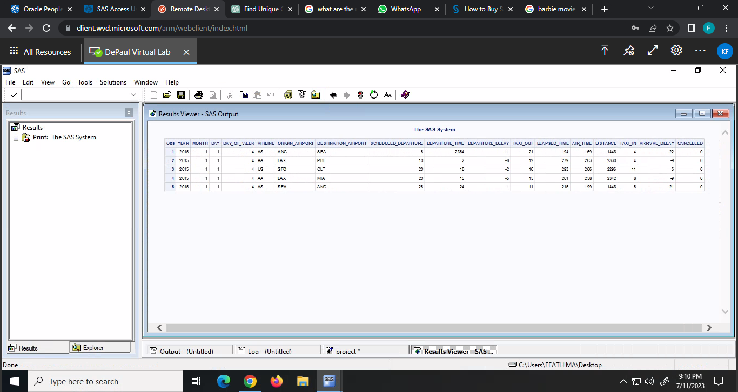Figures:

Fig.1

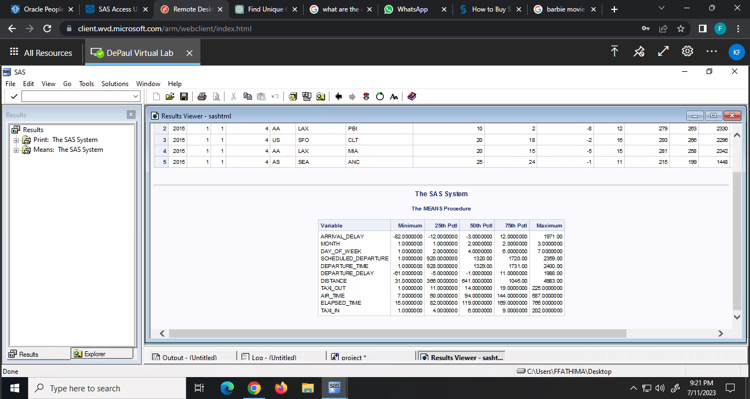

Fig.2

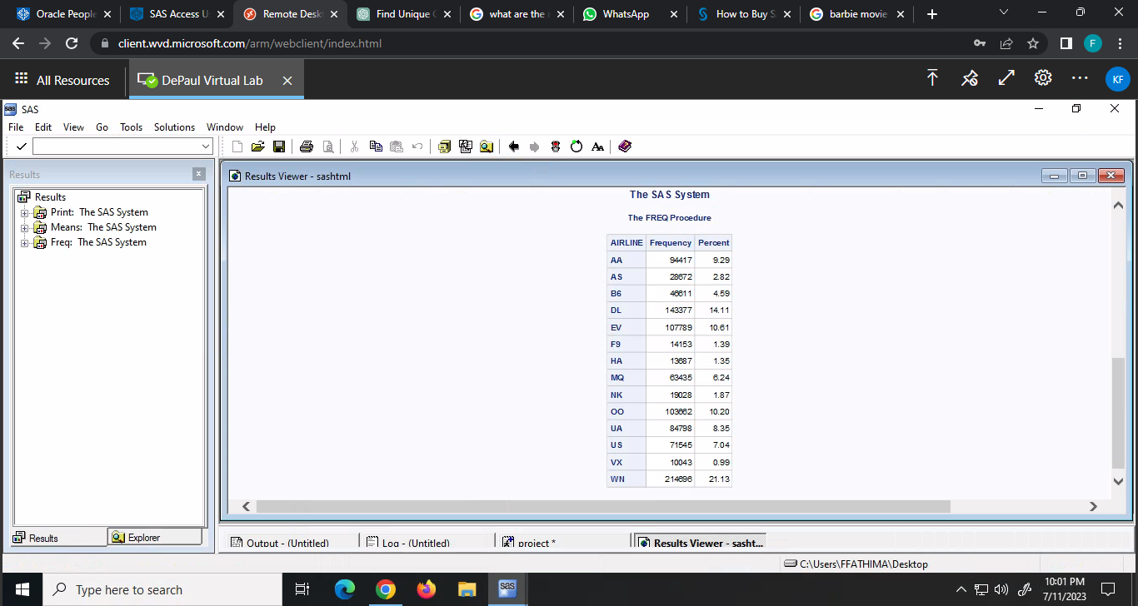

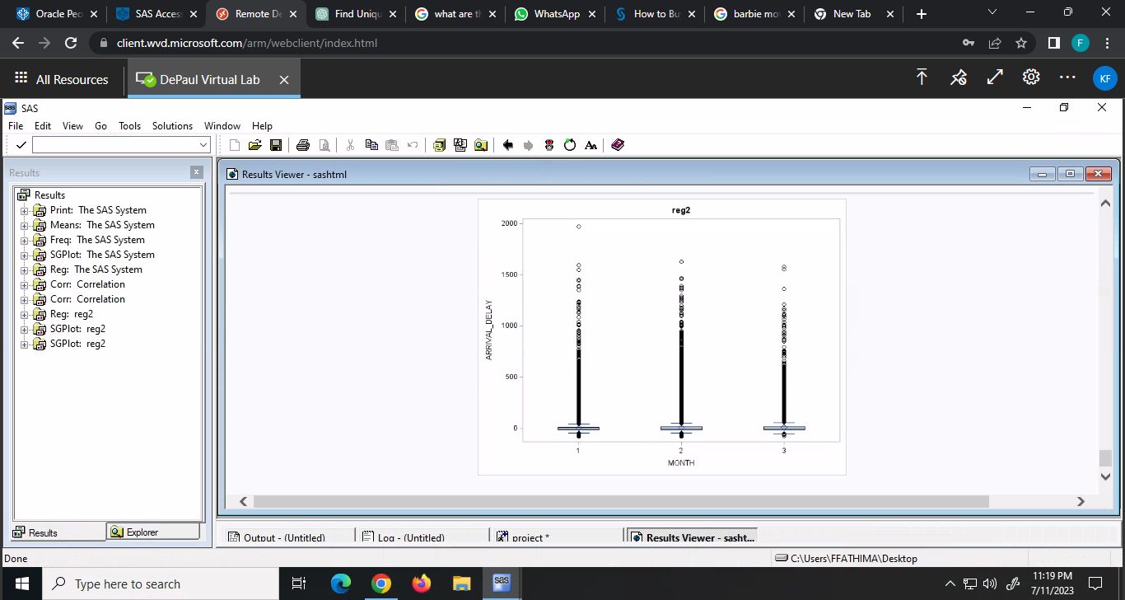Fig.3

Fig 4

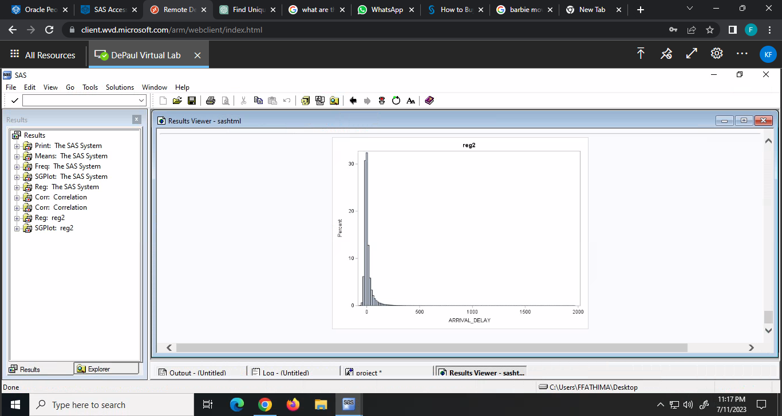

Fig.5

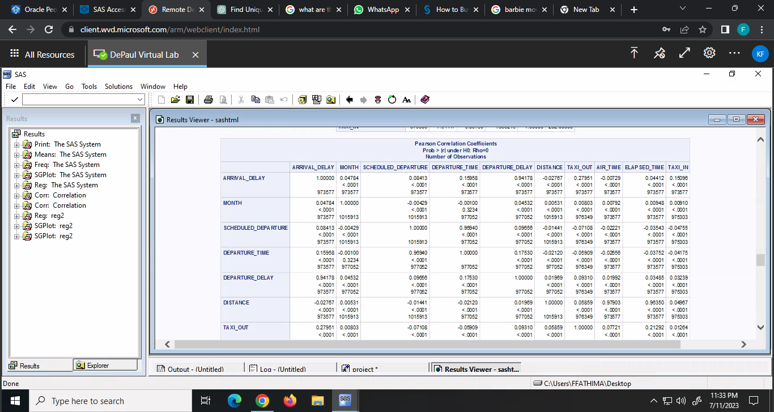

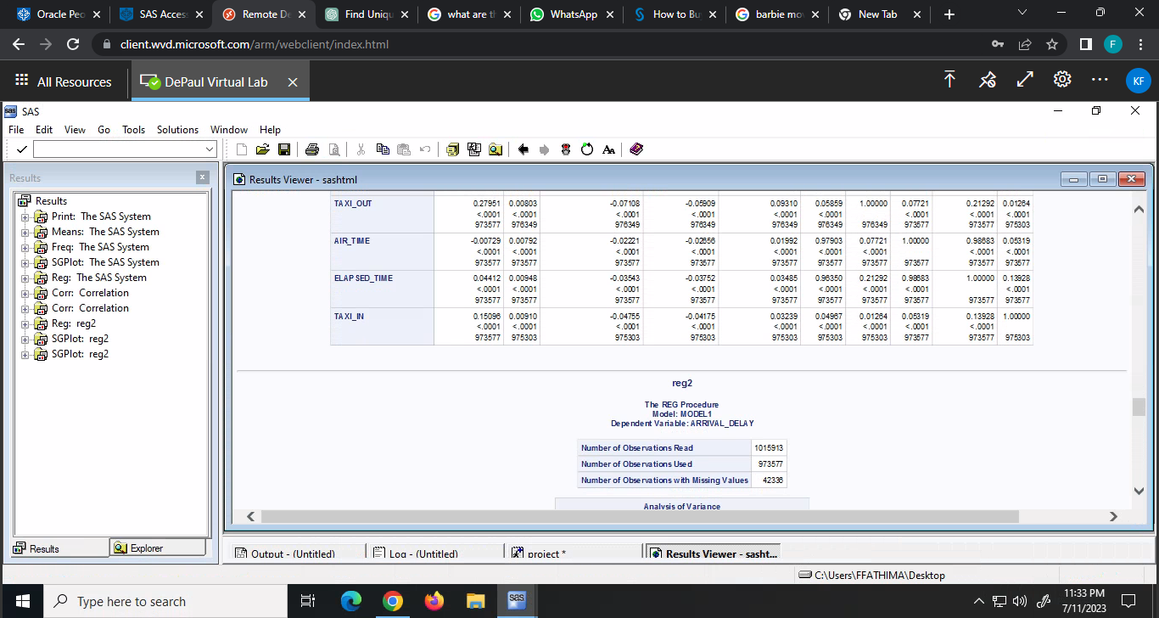

Fig.6

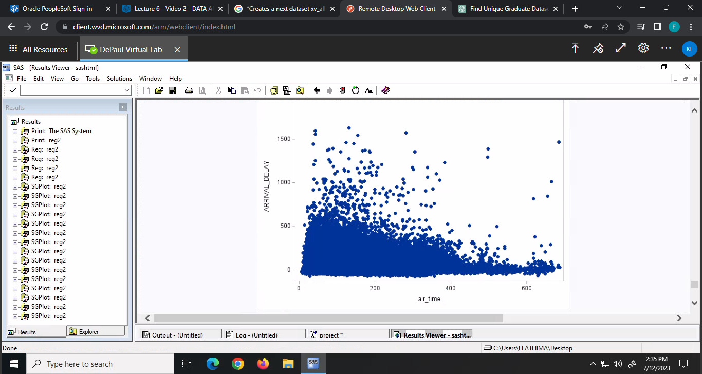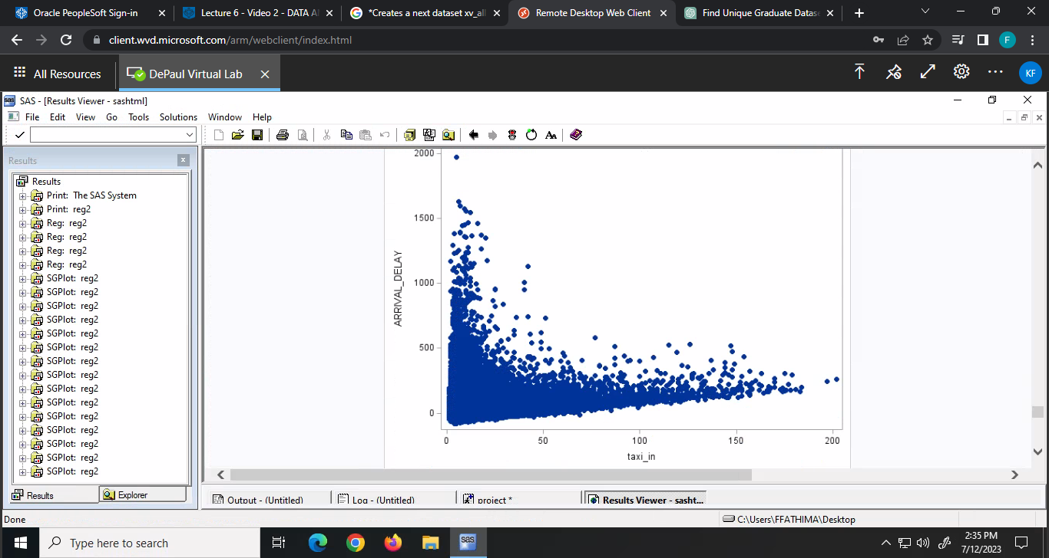

Fig.7.a Fig.7.b

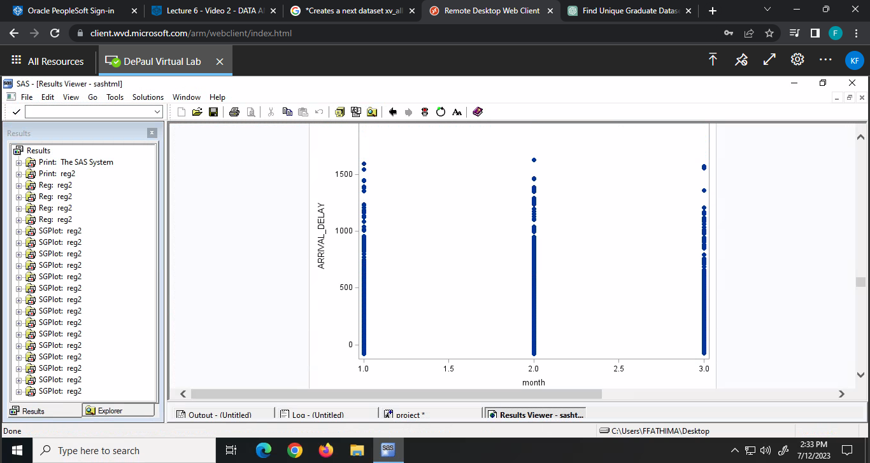 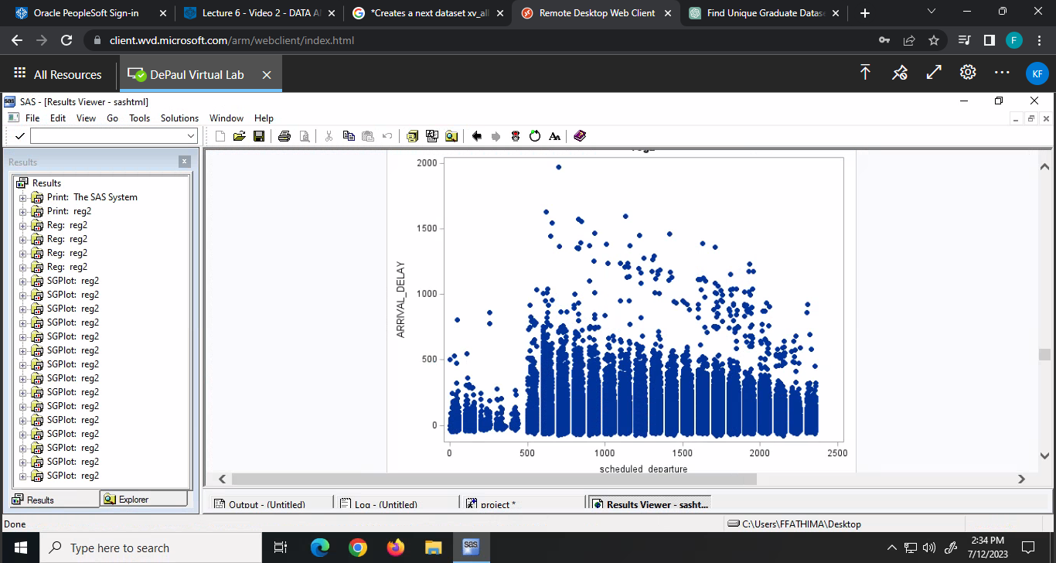

Fig.7.c Fig.7.d

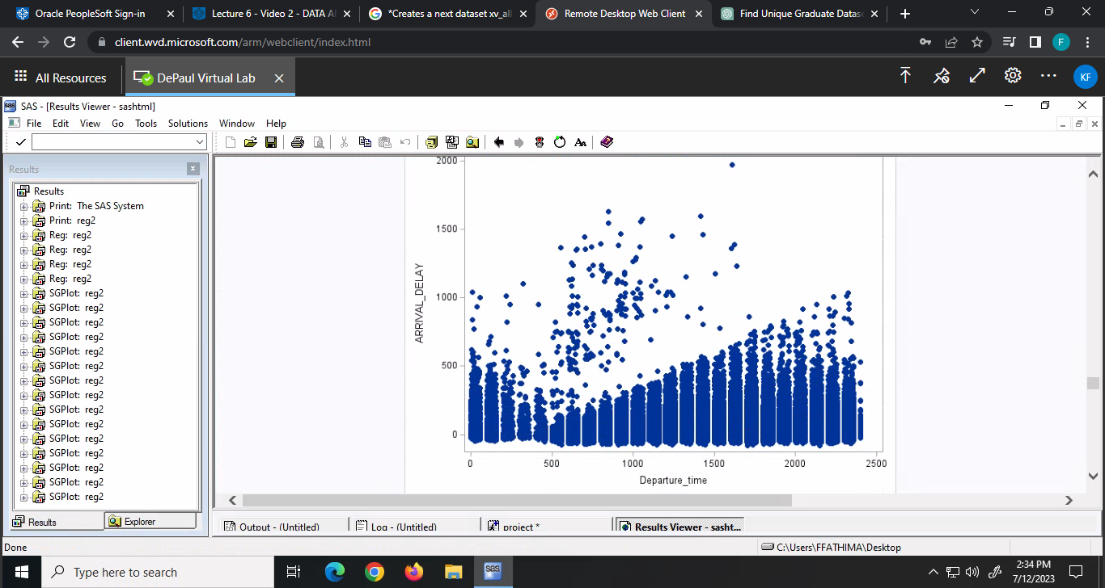 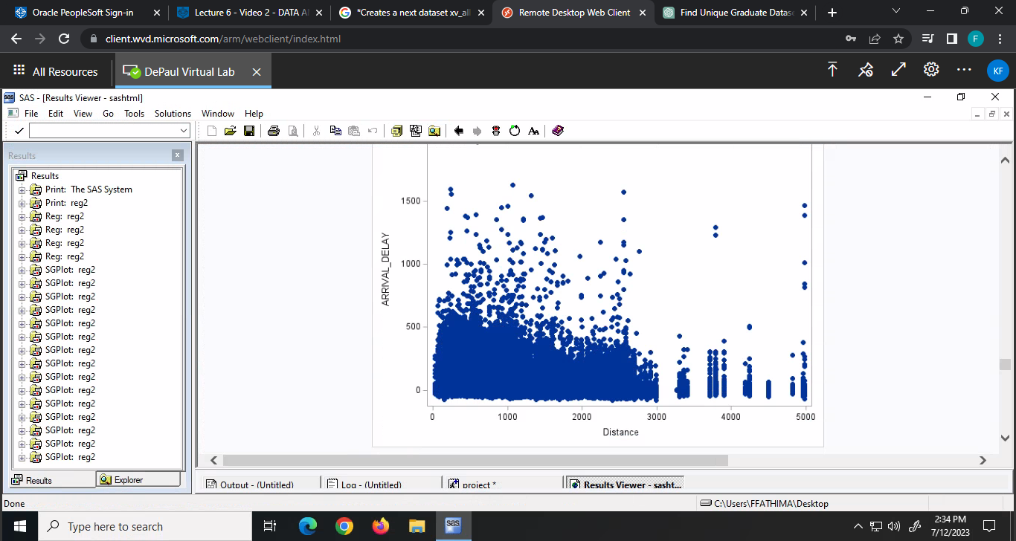

Fig.7.e Fig.7.f

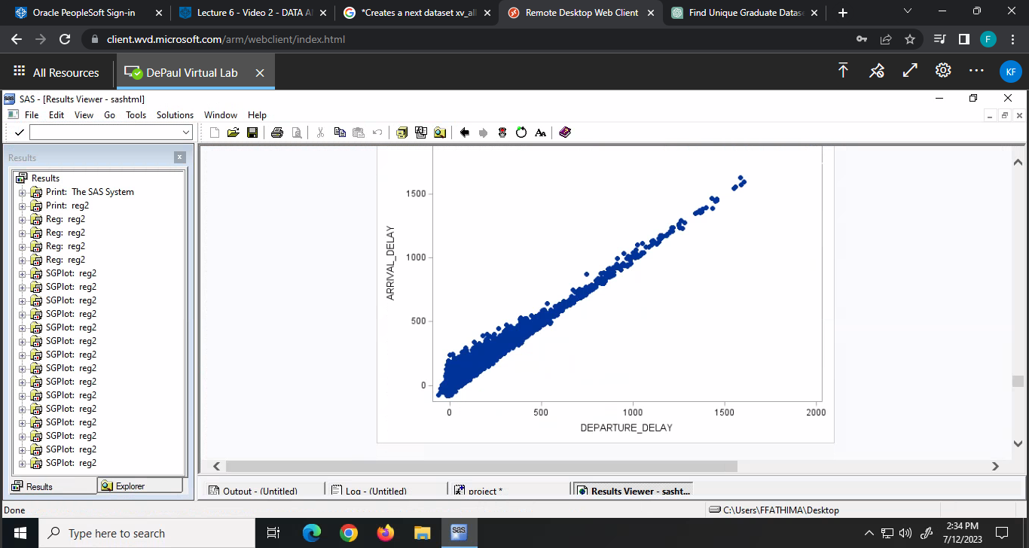 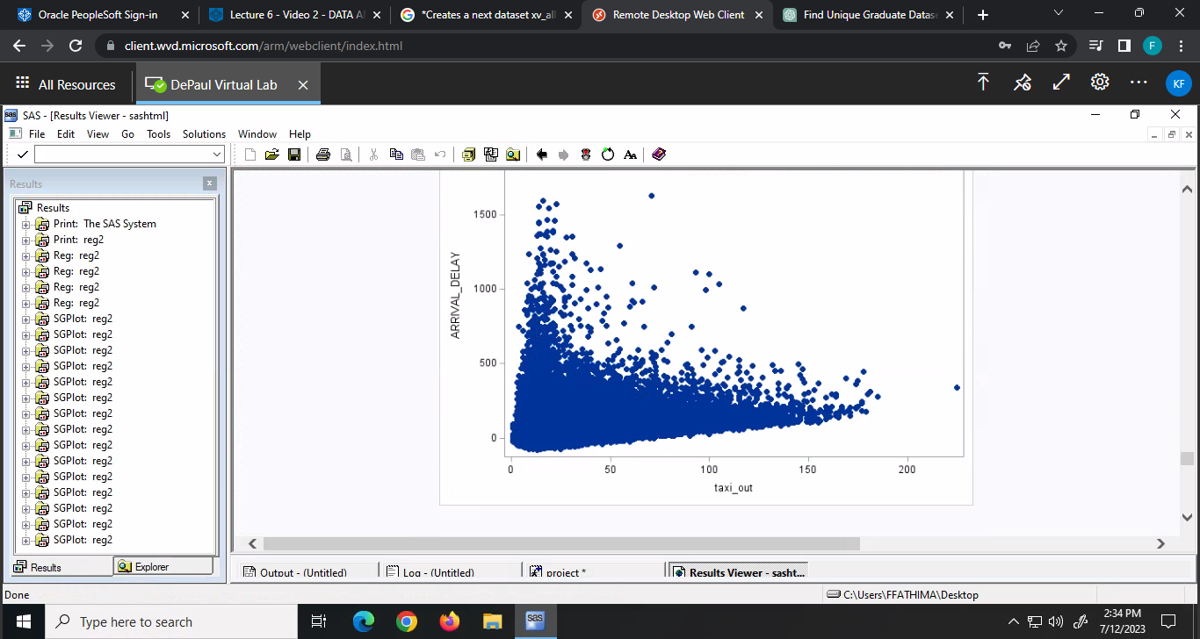

Fig.7.g Fig7.h

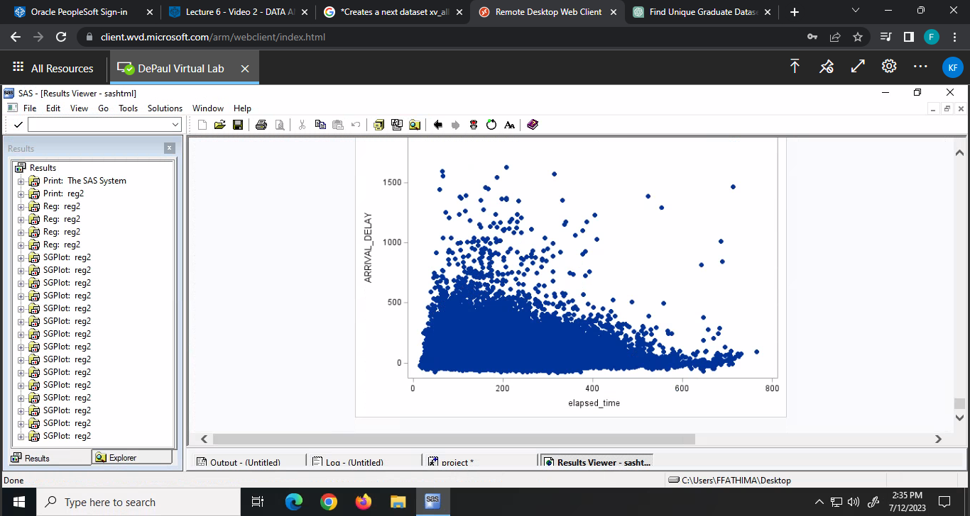 Fig.7.i

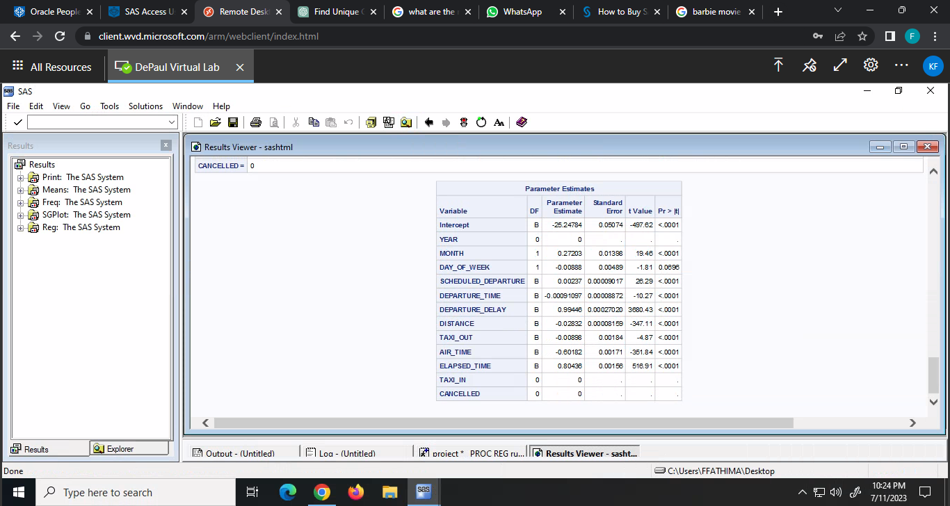

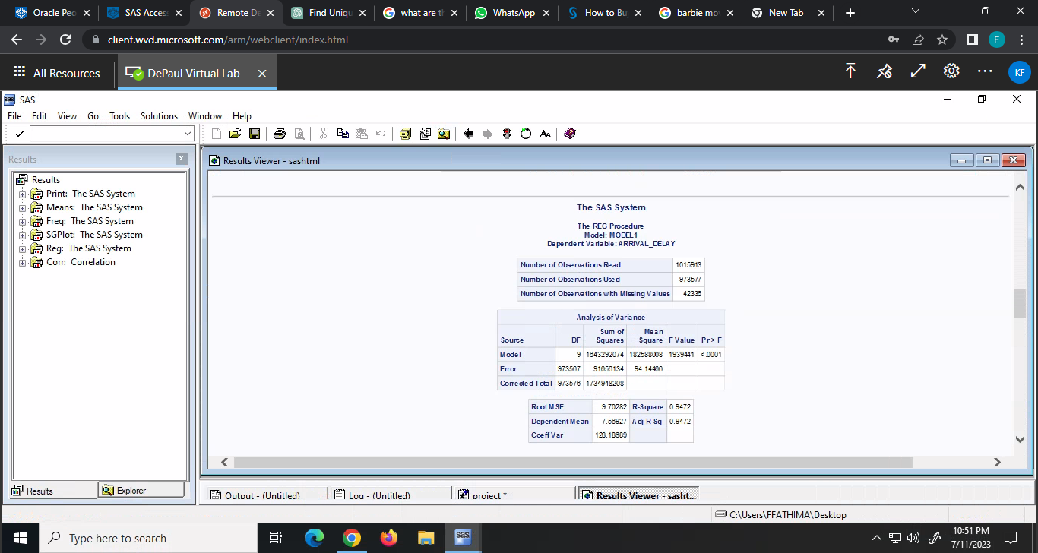

Fig.8 Fig.9

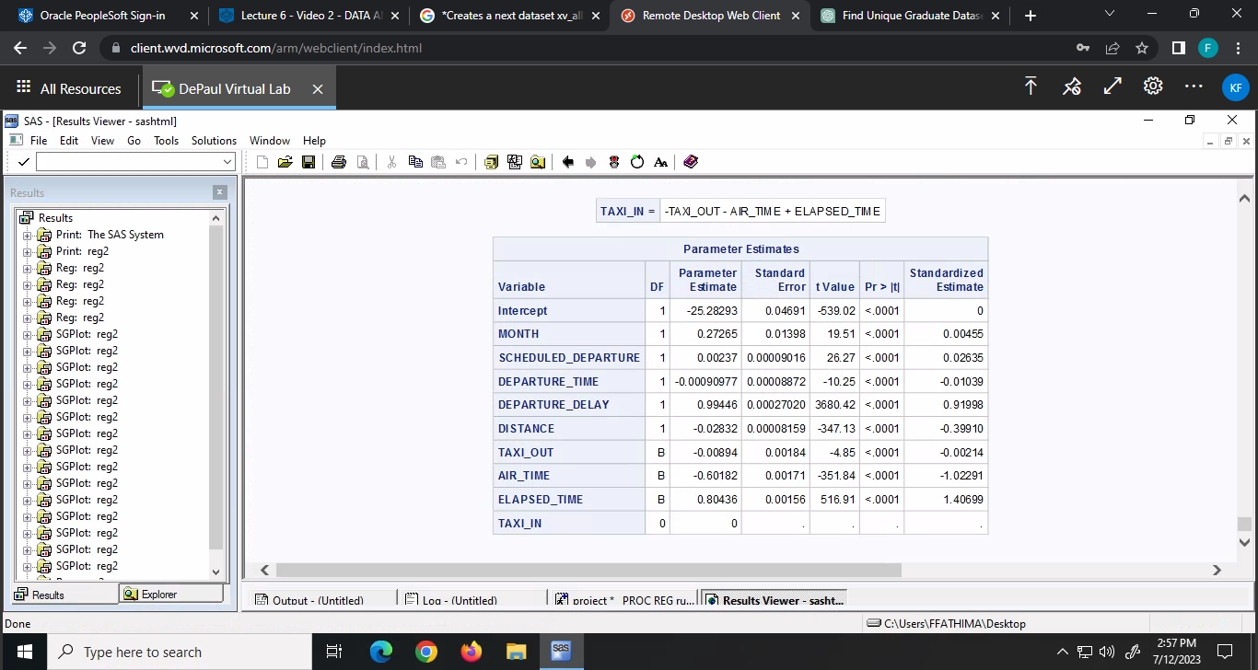

Fig.10

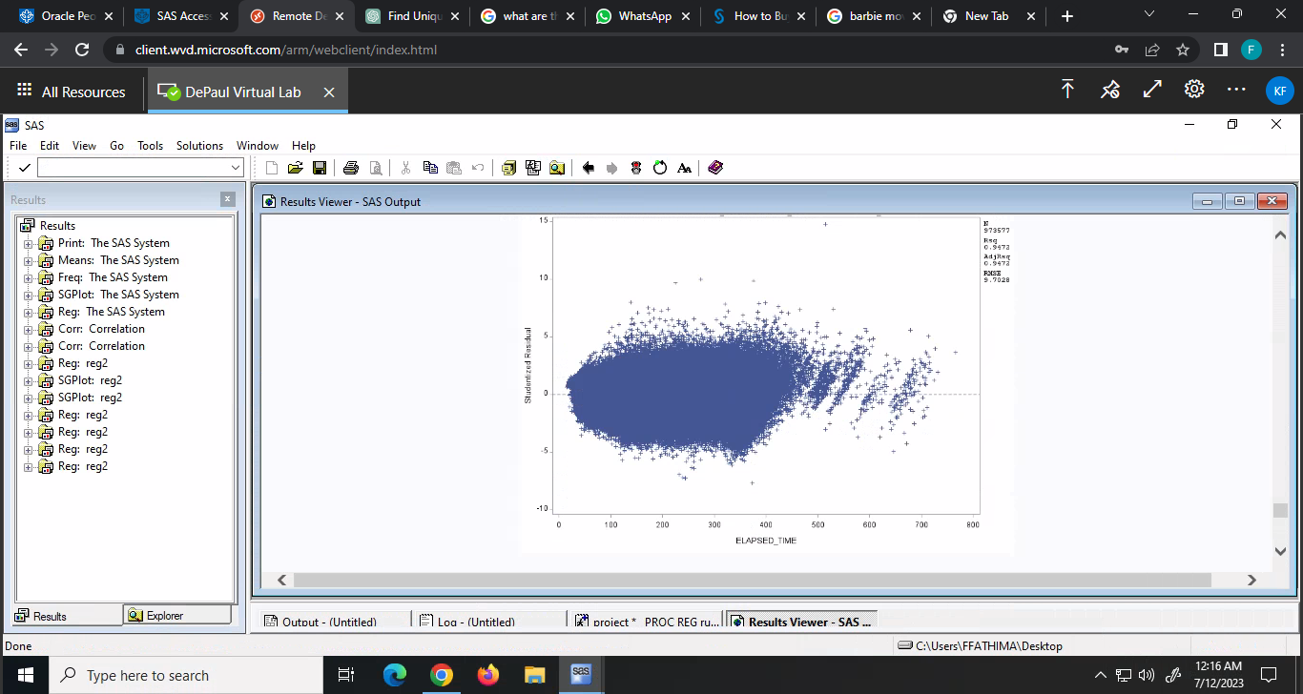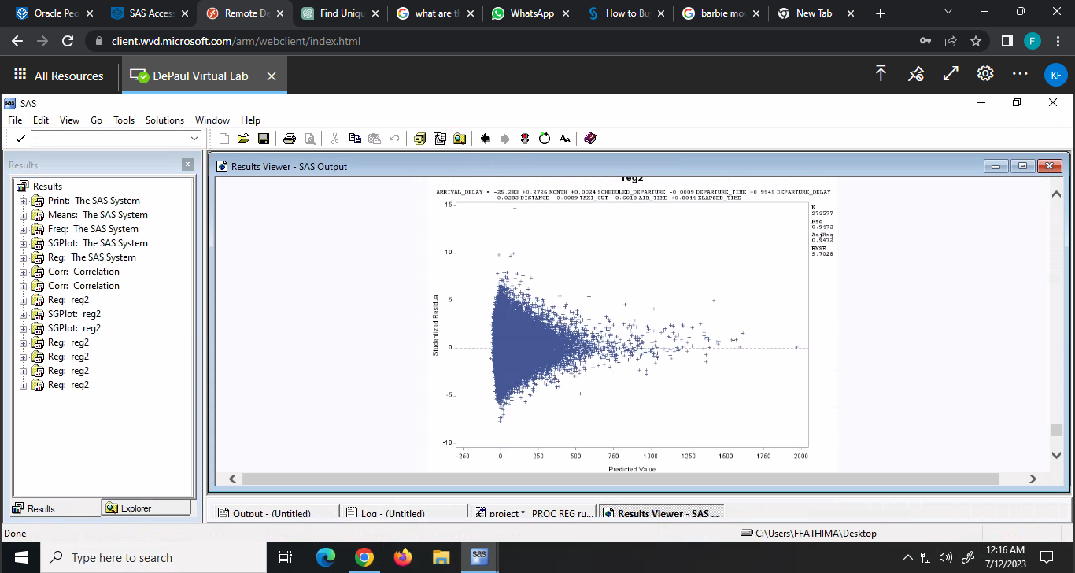

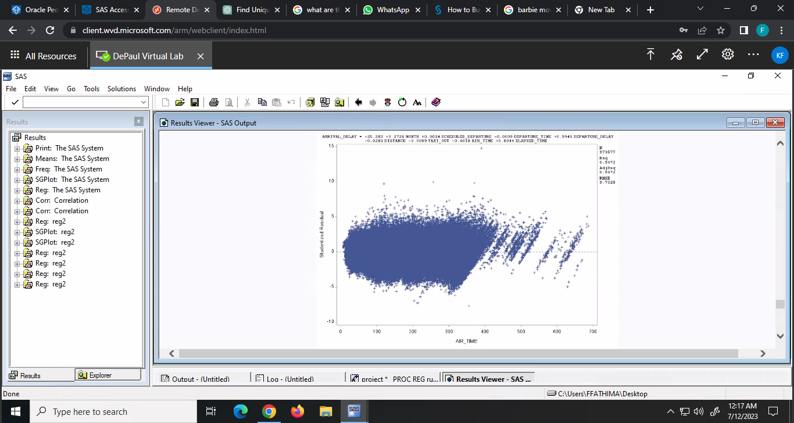 Fig.11.a Fig.11.b

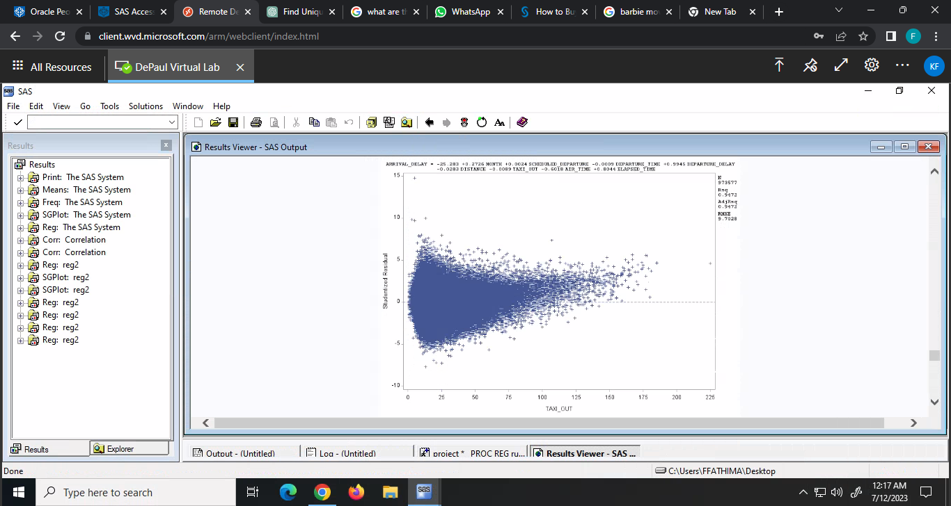

Fig.11.c Fig.11.d

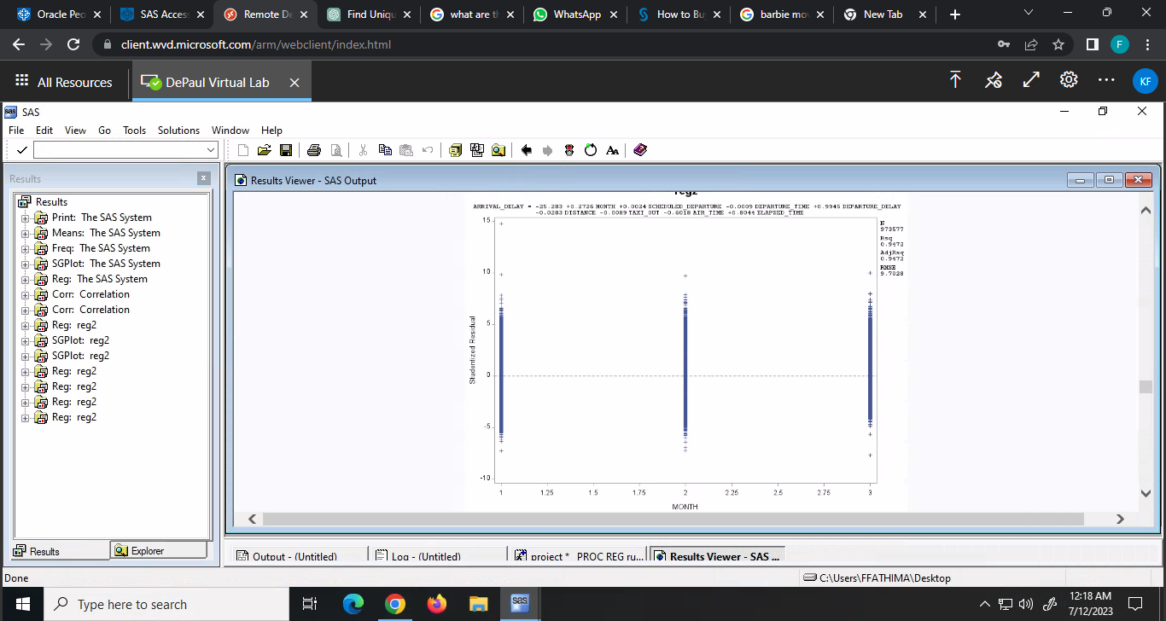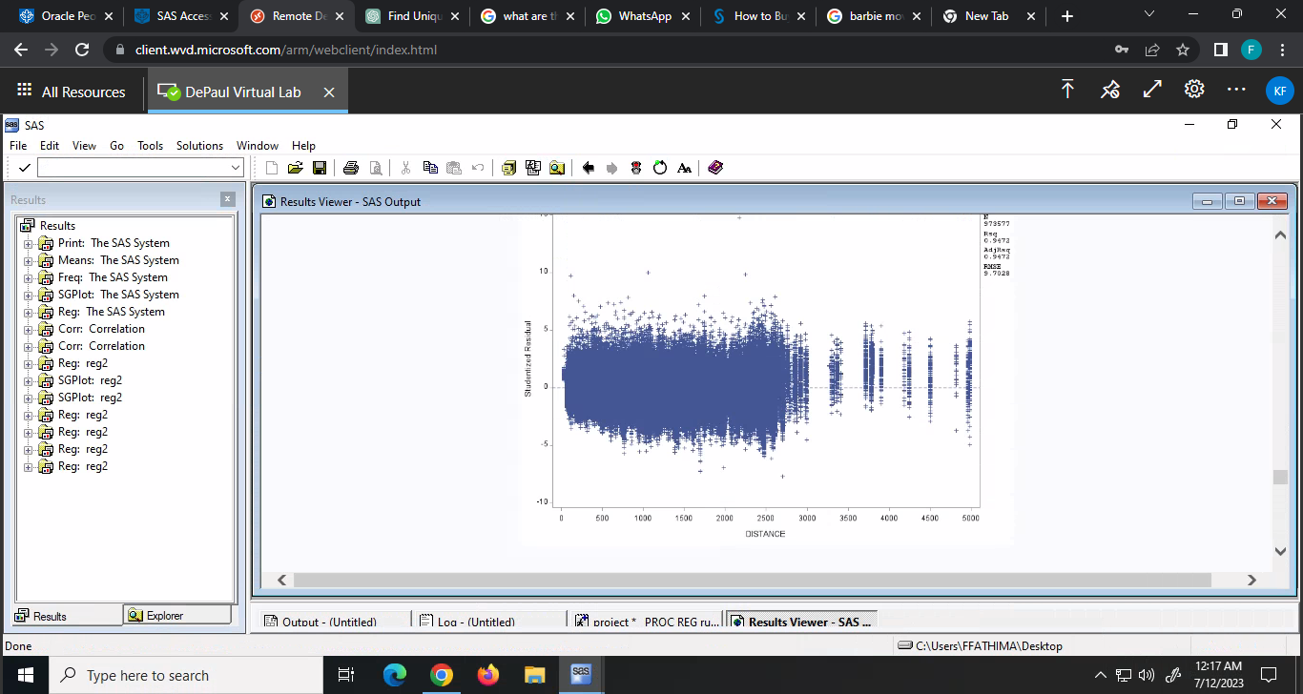

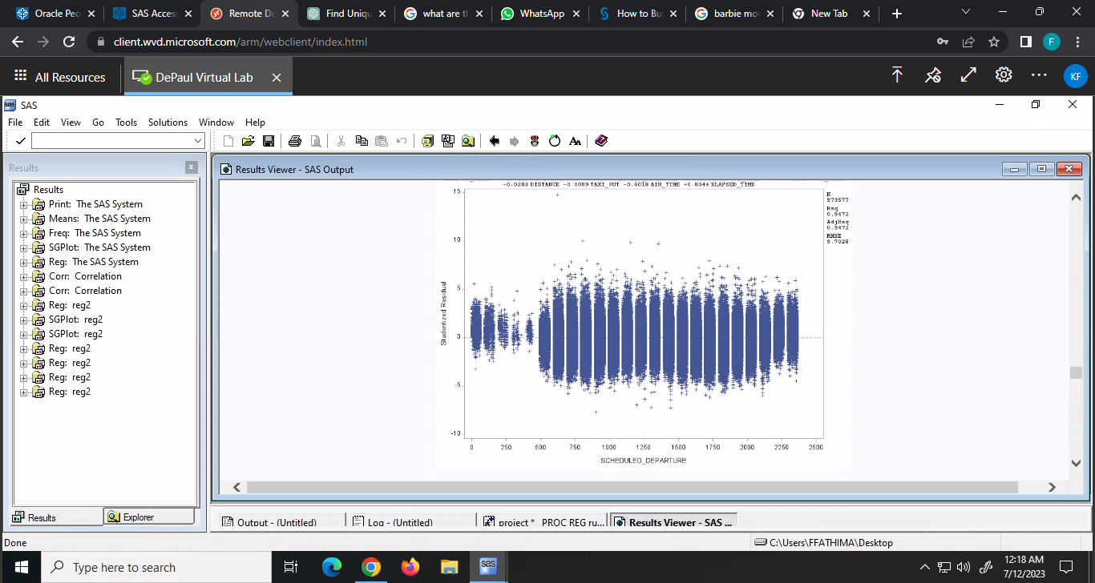 Fig.11.e Fig.11.f

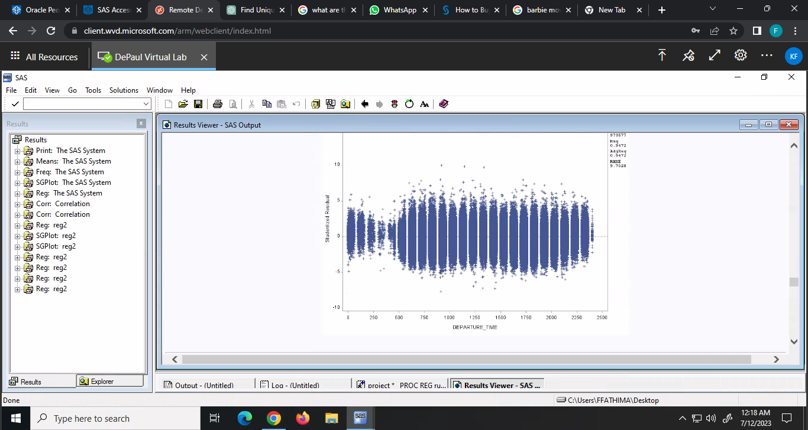

Fig.11.g Fig.11.h

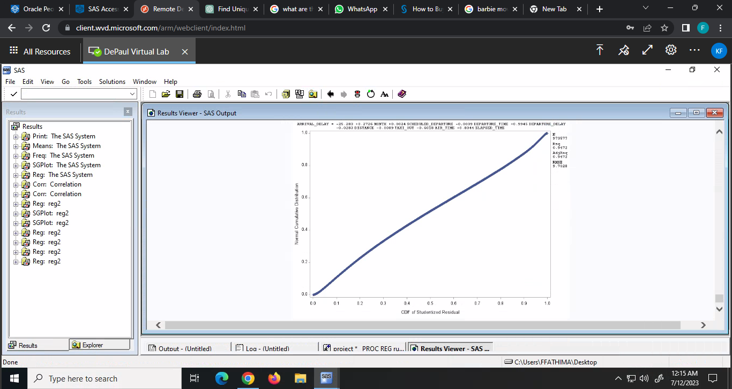 fig.11.i

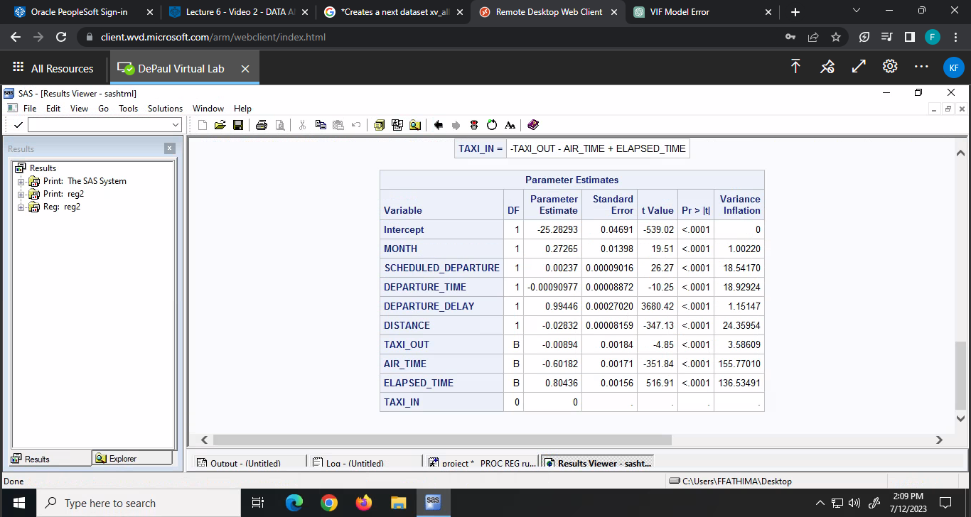

Fig. 12

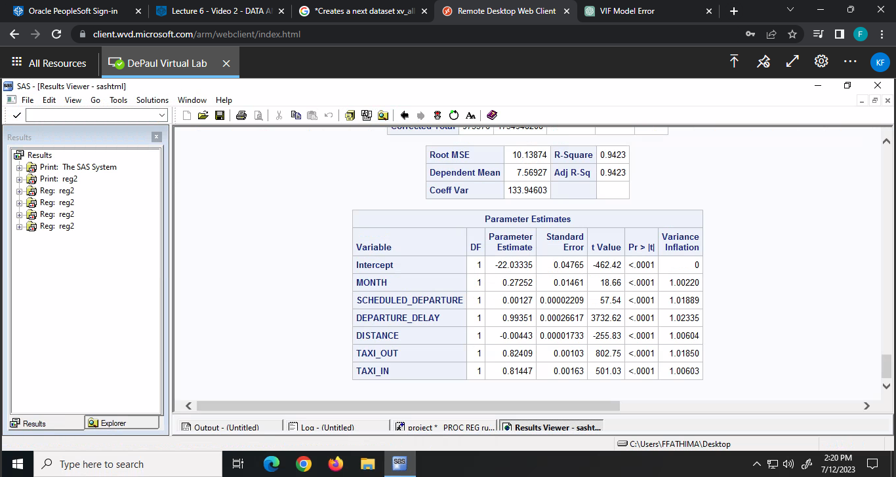

Fig.13

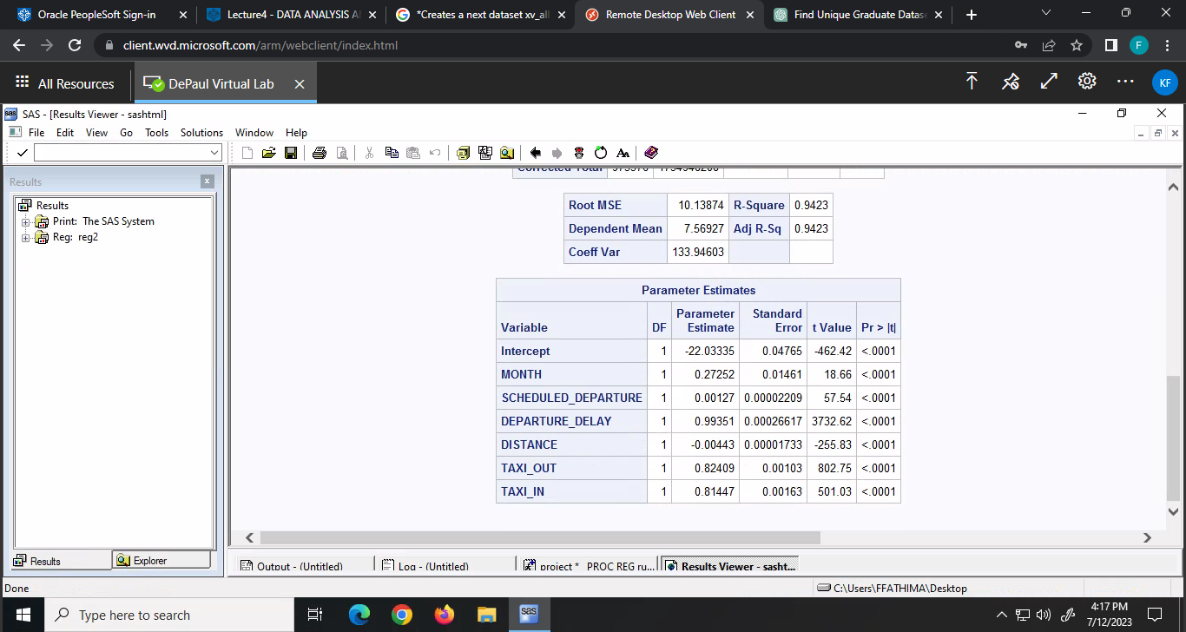

Fig.14

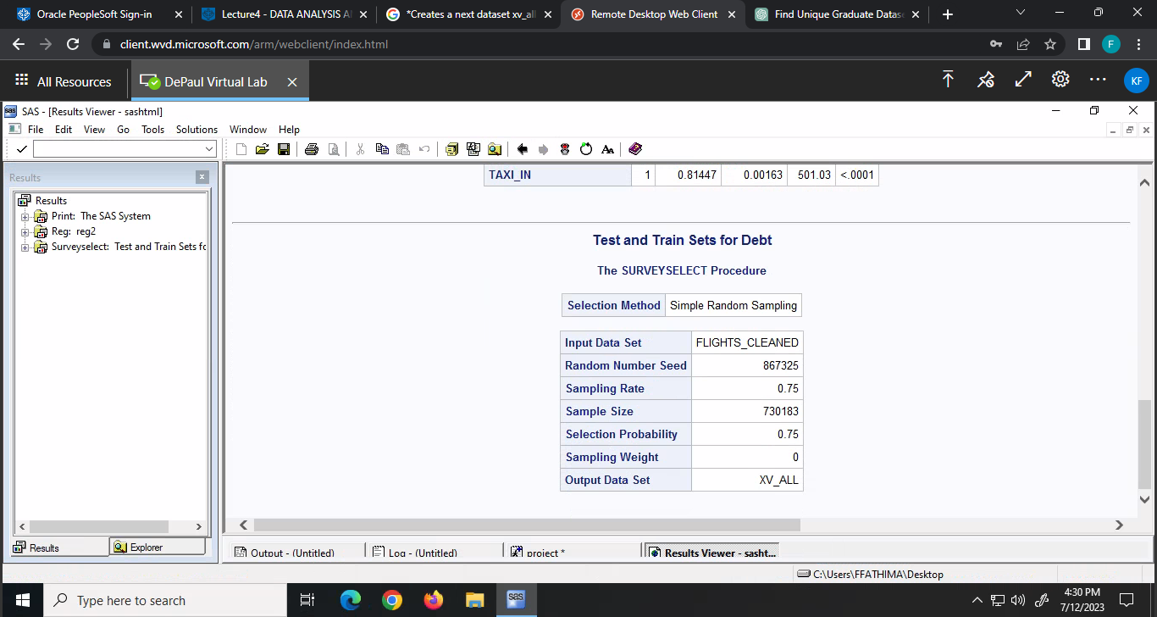 Fig. 15

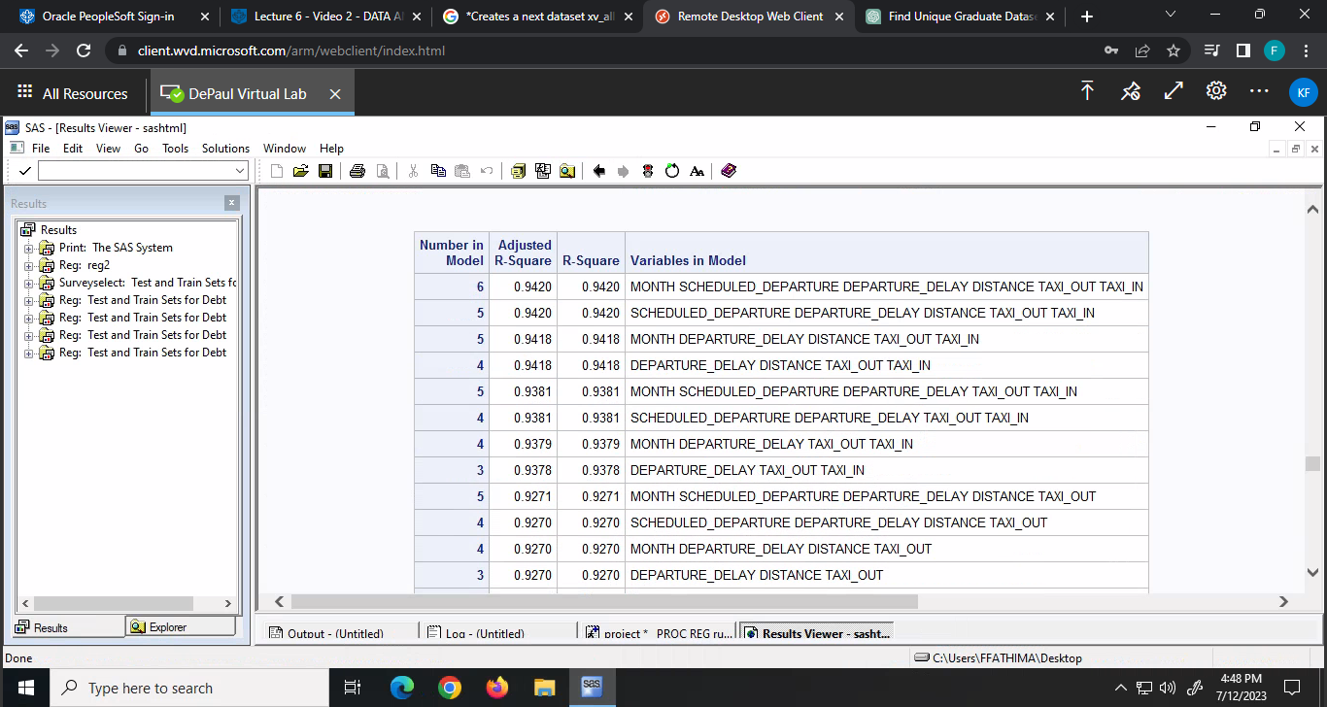

Fig.16

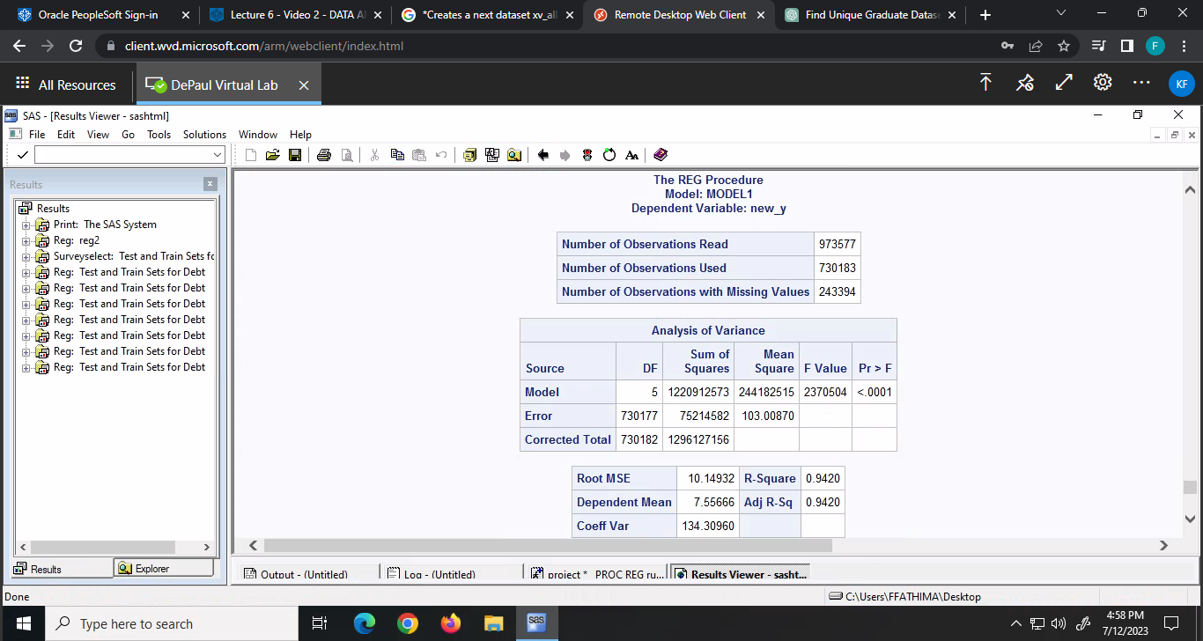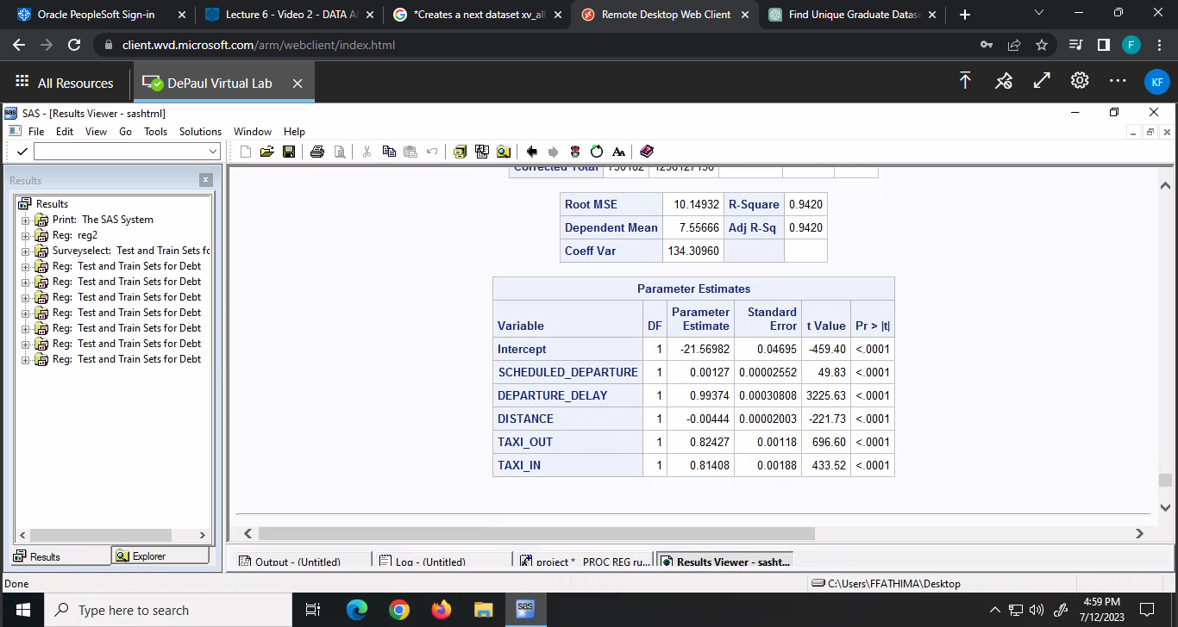

Fig.17

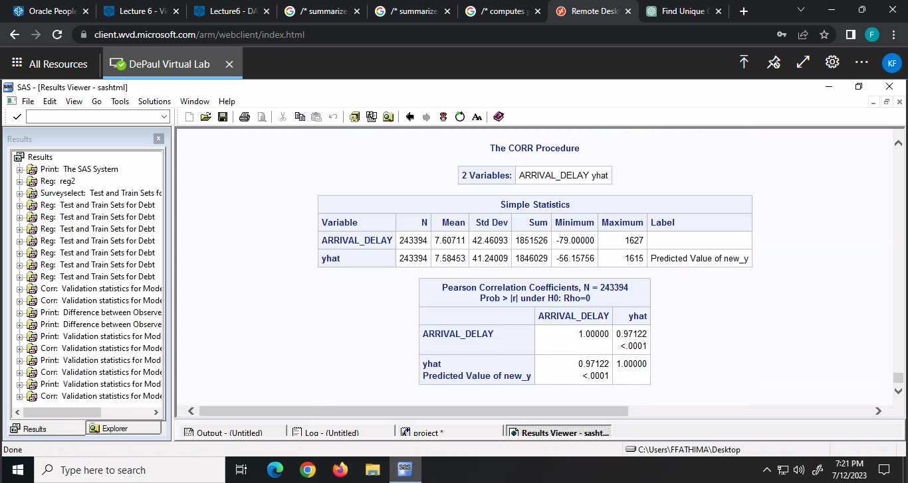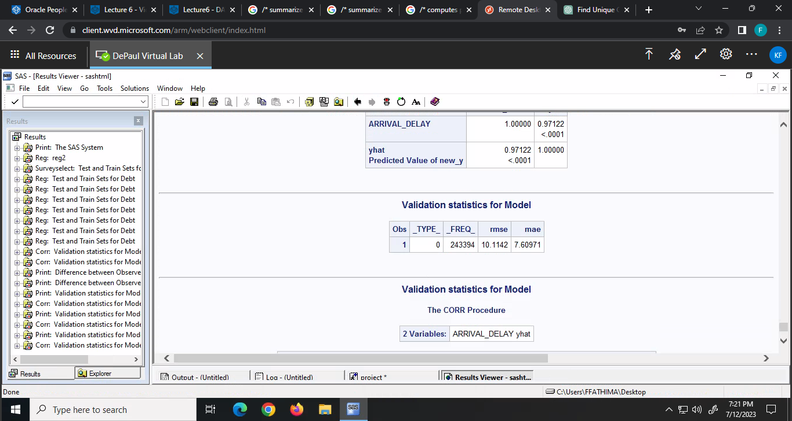

Fig.18

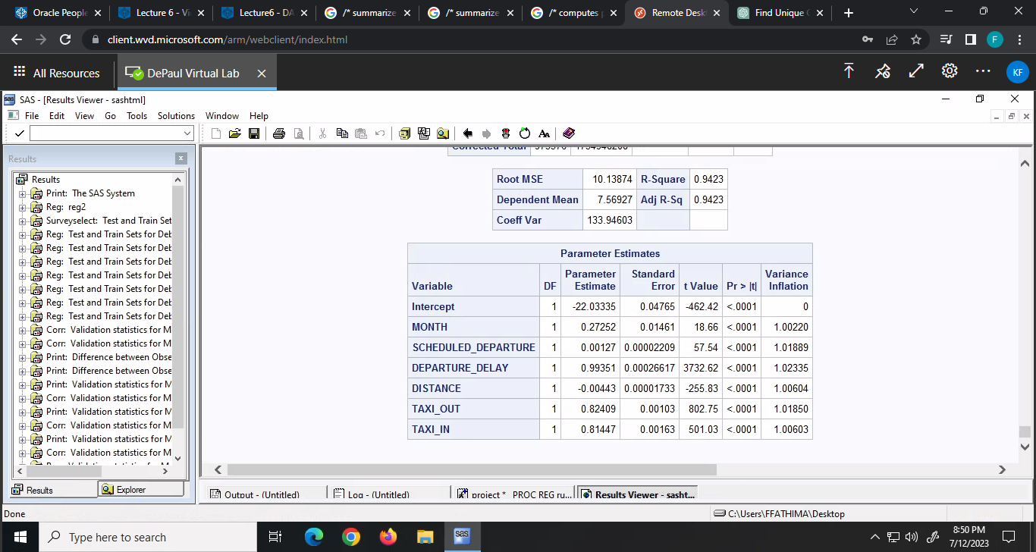

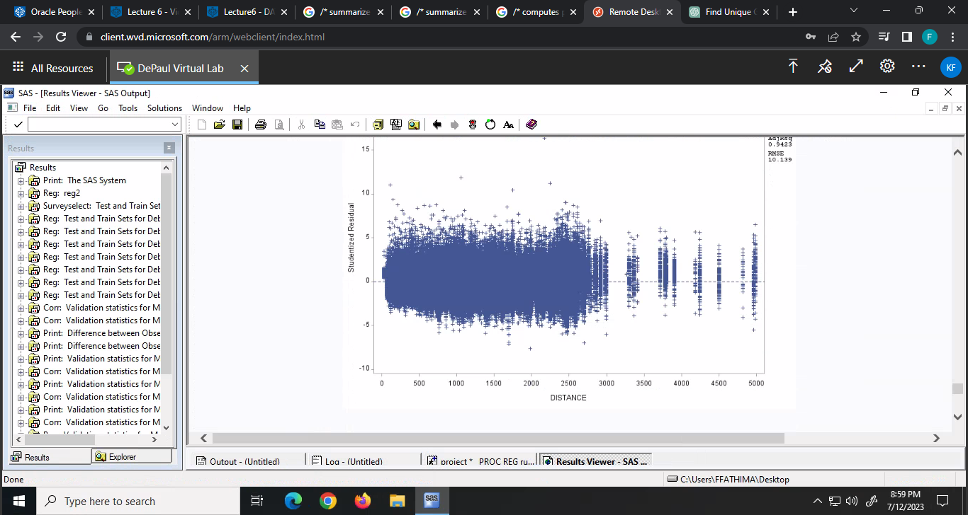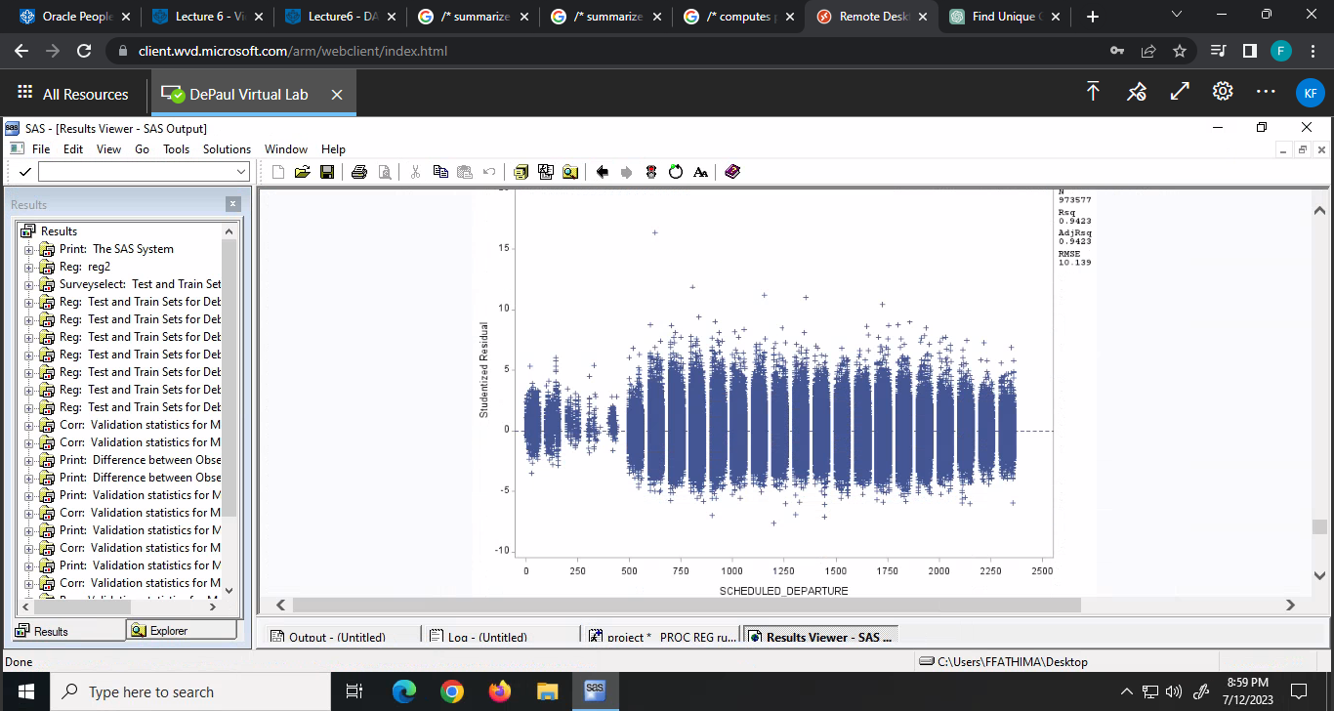Fig. 19

Fig. 20. A Fig.20.b

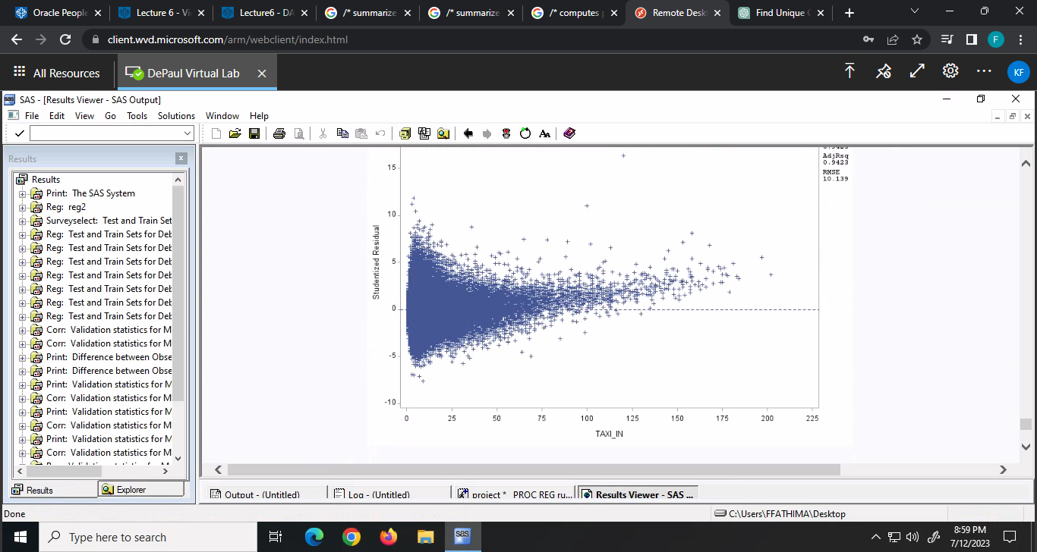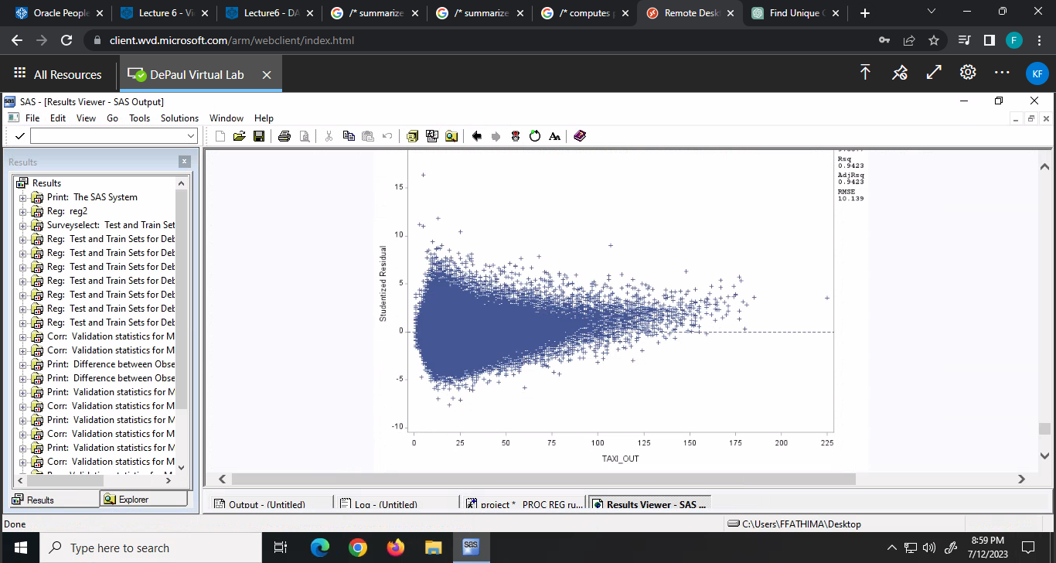

Fig. 20.c Fig.20.d

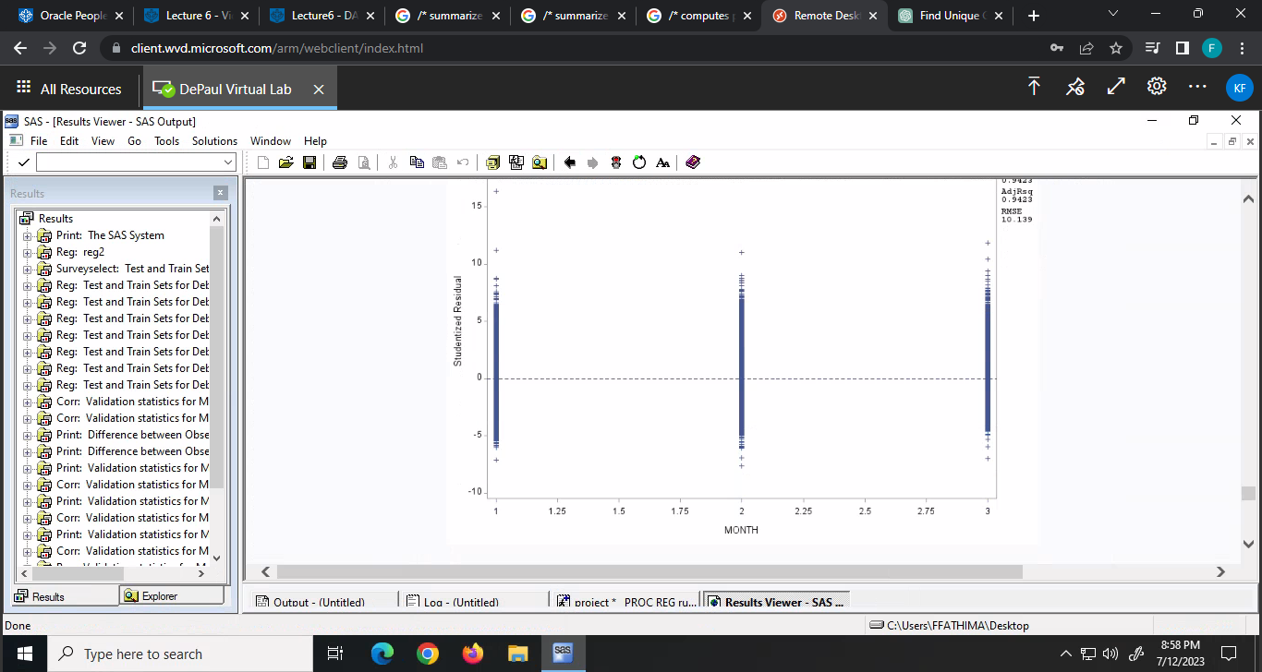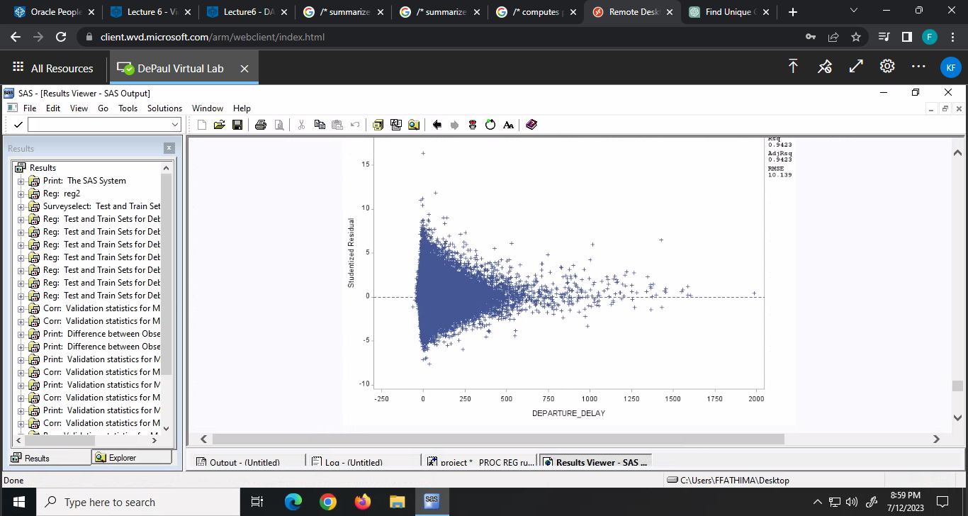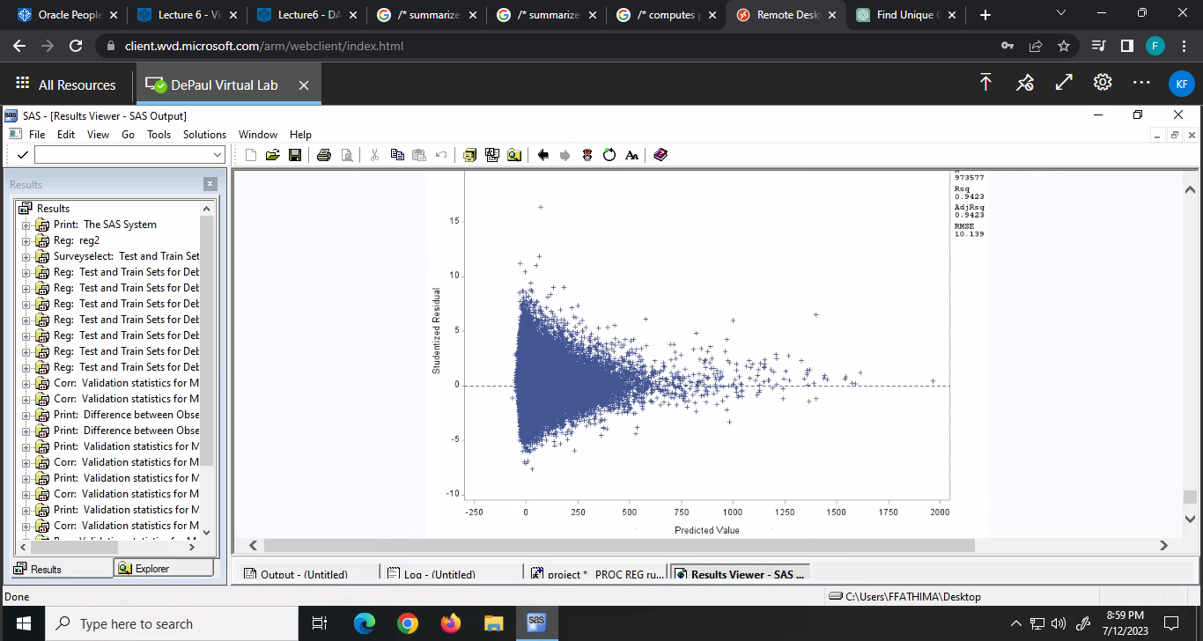

Fig.20.f

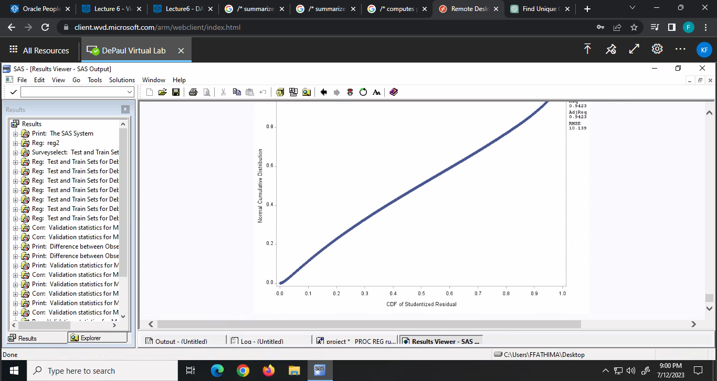 Fig.20.e

Fig. 20.g Fig.20.h

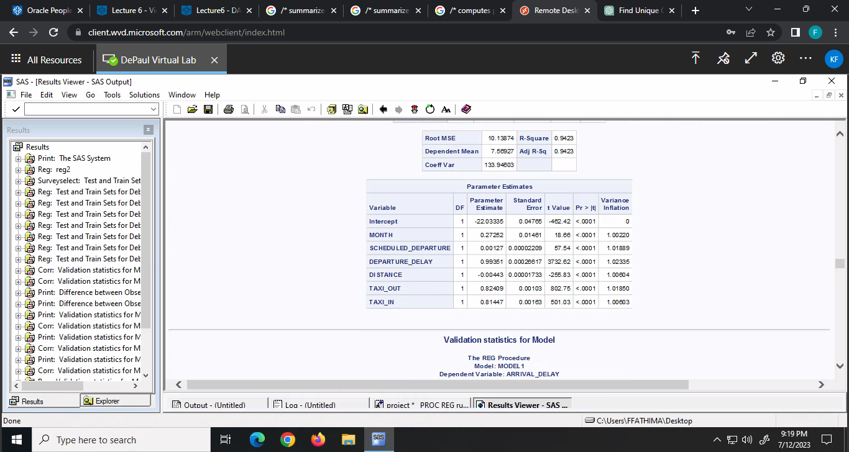

Fig.21

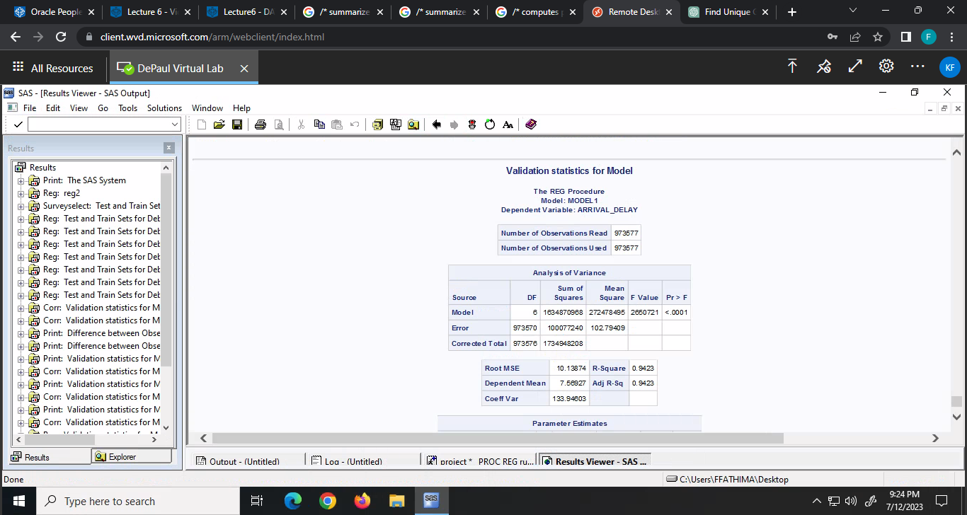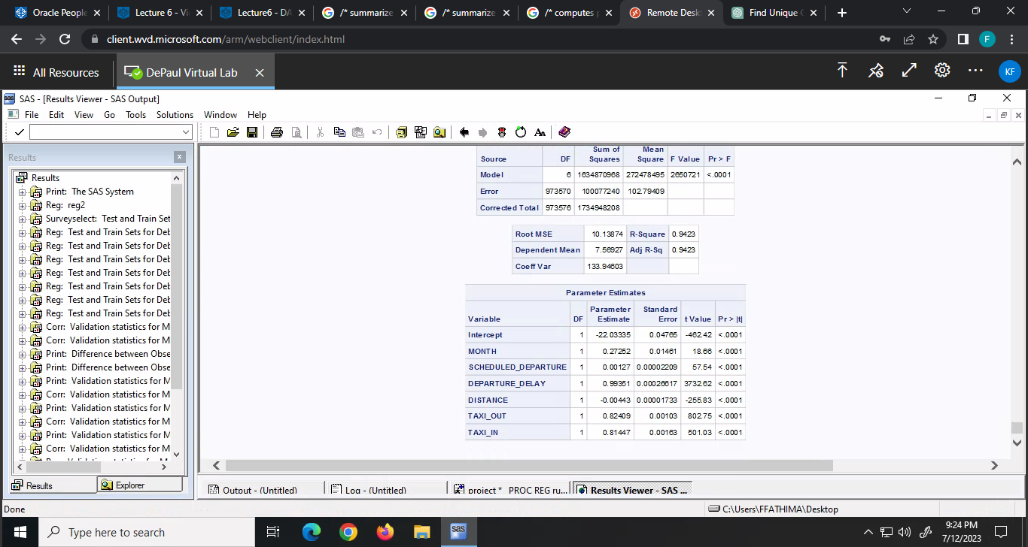

Fig. 22 Fig.23